**Simulink Series RLC Circuit**

Let L = 1 H, C = 15 micro farad, Vc(0-) = 5 V , i(0-) = 0 A

**Over damping when R = 800 ohm:**

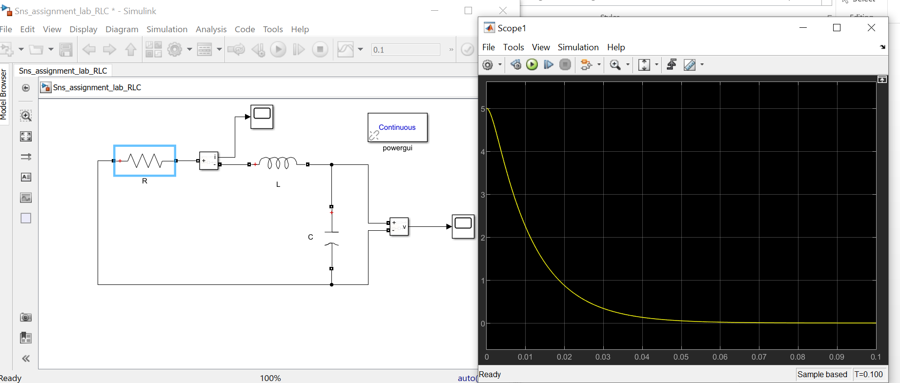

**Underdamping when R = 100 ohm:**

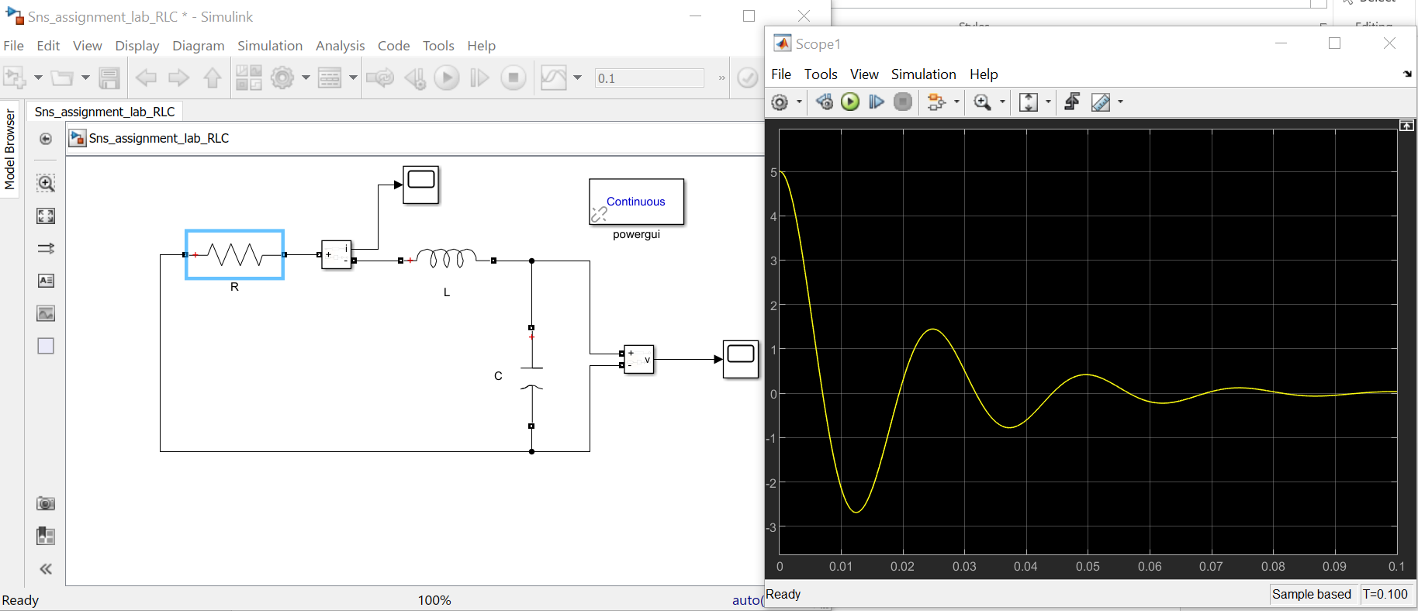

**Critical damping R = 516.4 ohm:**

